YourBestPet

User Manual

NESCOL |30082939

2023

Table of content:

Introduction 2

Welcome page 2

Petbook 3

Dog finder 5

Cat Finder 7

Pet finder 8

Tips 9

# Introduction

Welcome to our pet selection and care app! Are you considering getting a furry friend but don’t know which one to choose? Or perhaps you already have a pet but want to learn more about how to provide the best care possible? Look no further - our app is here to help! With our app, you will have access to a wealth of information about pet care, from nutrition and exercise to grooming and health. But that's not all - we also offer a fun and interactive quiz that will help you find the perfect pet for you based on your preferences and lifestyle.

The application has been divided into three main sections: the top section where the logo is displayed, the middle section containing all current information, and the footer section where you can find buttons directing you to all the functions of the application. Always in the same place! And they change colour depending on which tab you have open!

# Welcome page

Here is the main window of the application. Every time you start the program, this window will be displayed. If you are interested in the application, read the message carefully, because after moving to other functions, this message will disappear until you restart the application!

# Petbook

Here is the encyclopedia of all dogs and cats available in the application! There is a scrollbar on the right side. Use it to browse the content. Animals have been divided into two categories: dogs and cats, and each is marked by a color change. Enjoy reading!

# Dog finder

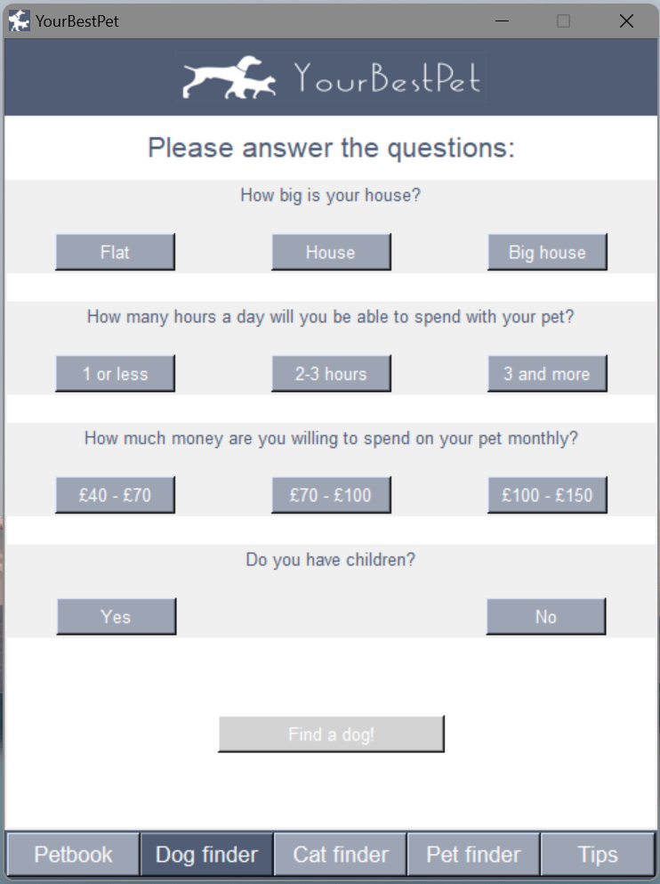 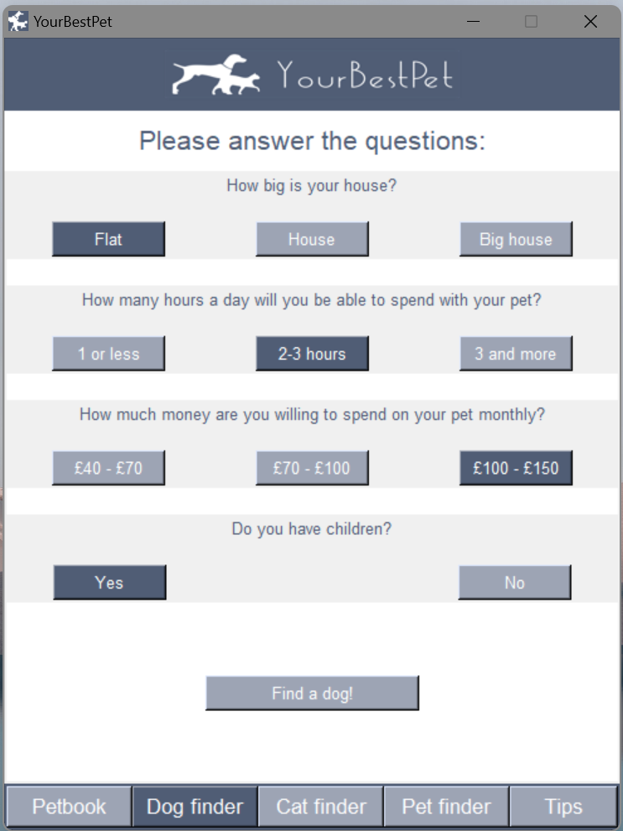

Here is one of our quizzes! Answer all the questions, and the "Find your dog!" button will change color. This means that you can proceed and find your dream pet!

Note that the button at the bottom of the page can be in one of three states.

Inactive - you have not yet answered all the questions.

Active - all the answers have been given. Press the button to find a new friend!

Informational - your answers do not match any of the dogs in the encyclopaedia. Perhaps you can increase your funds or become a bit more active? You can always change your answer and press the button again!

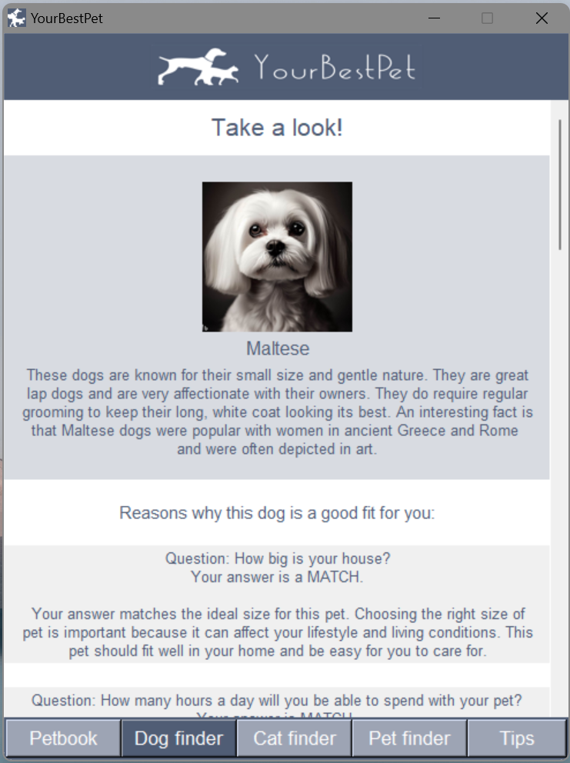 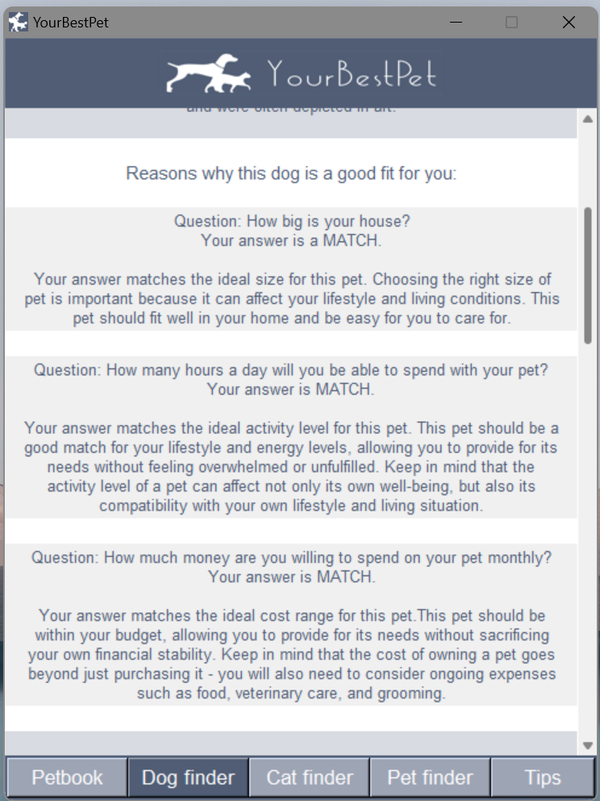

Here is the result of the quiz! If your answers match any dog/dogs, they will be displayed in alphabetical order and in a specific layout - first the animal card with basic information, then information on why this pet is a good fit for you, and if some of your answers do not match this particular animal, they will also be displayed at the end.

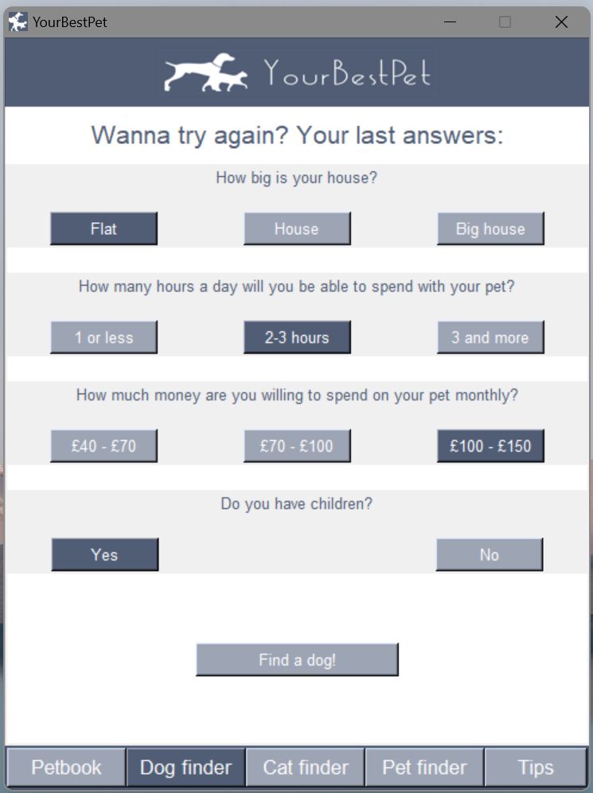

You can always go back to the quiz by clicking on the "Dog finder" button at the bottom of the application. The title will be changed to remind you that you have been here before, and your previous answers will be displayed so that you can easily change only the ones you are interested in!

# 

# Cat Finder

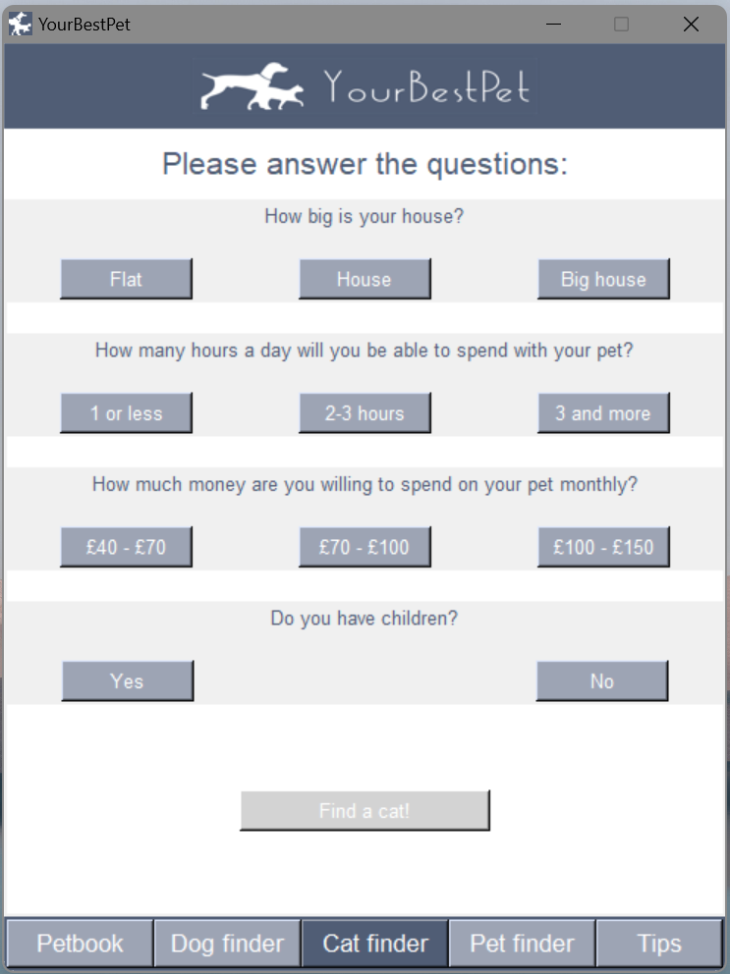 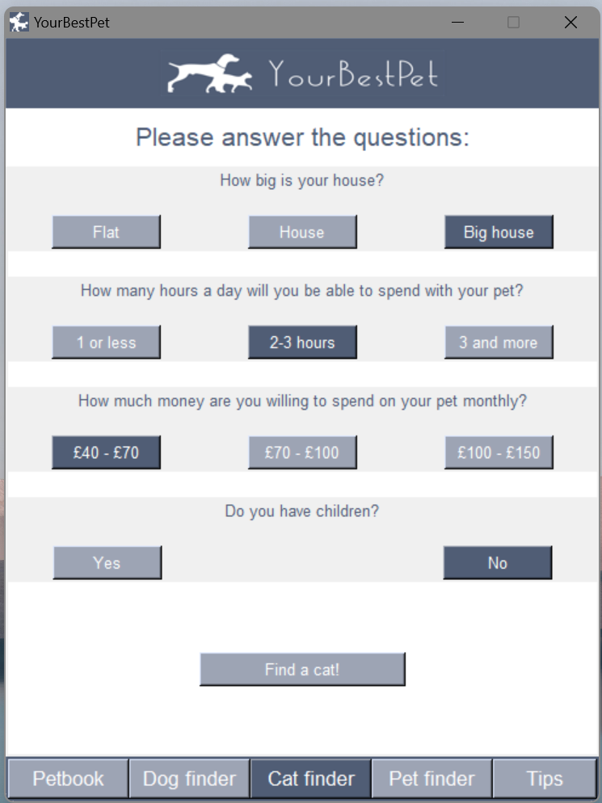 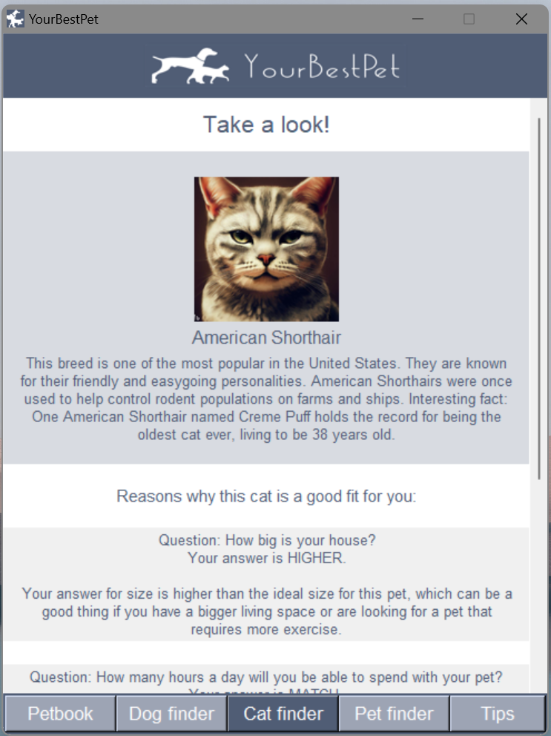

Here is the next quiz! We won't take up too much of your time. We'll just say that this quiz works exactly the same as the Dog finder. Answer the questions and find the cat that suits you best!

All of our quizzes work independently of each other, so when you return to any of them, your previous answers will be displayed to make it easier for you to work with our program.

# Pet finder

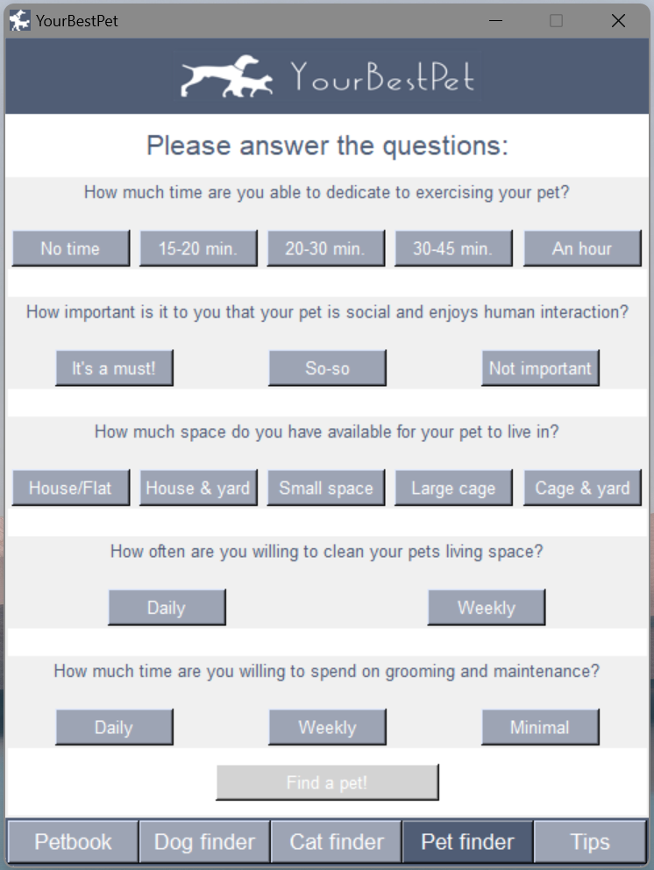 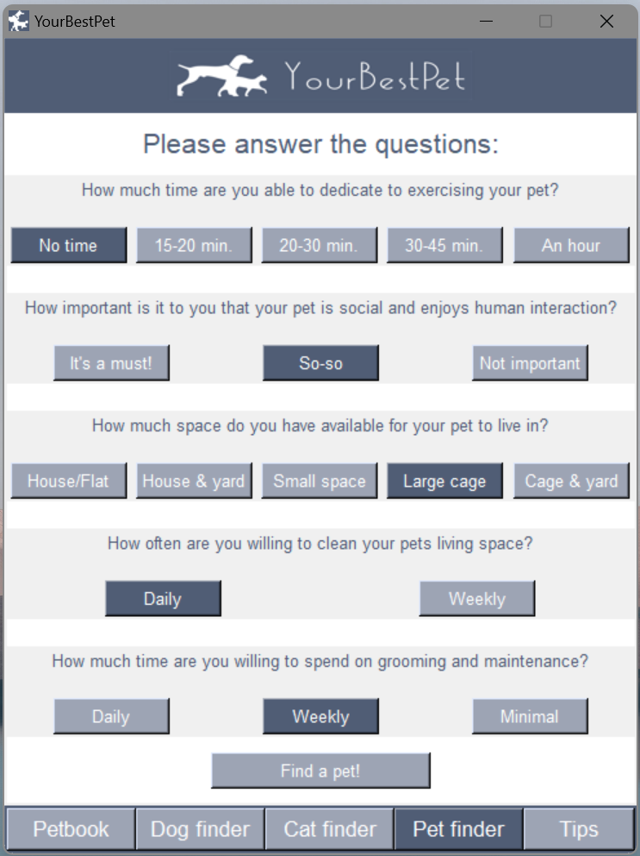

Last but not least! This quiz will help you find which animal suits you. Depending on your answers, it could be a cat, dog, rat, rabbit, or fish. Or maybe a few of them? You will receive very detailed information about the care, characteristics, and interesting facts about the specific animal as an answer.

# Tips

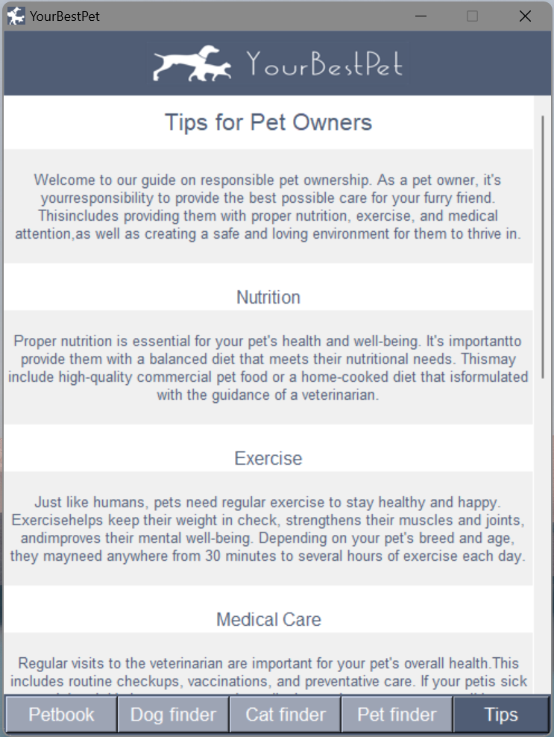 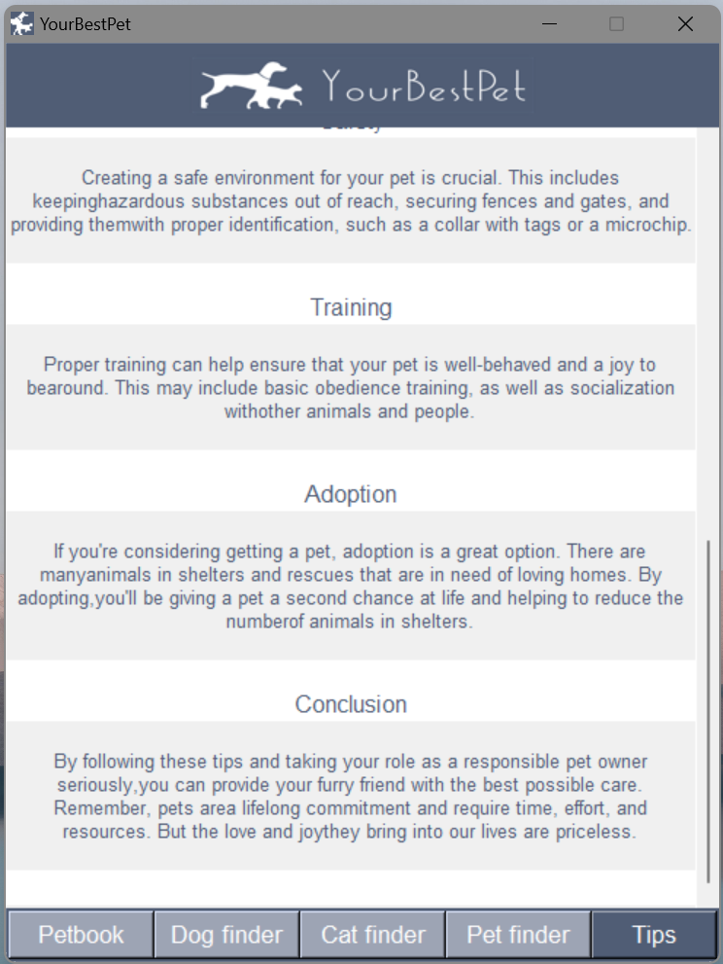

If you would like to learn how to become a responsible owner of a domestic animal to prepare for a new situation, check out our tips section. We've got you covered!